10 User Stories

1. Sign up member

2. Log in to account

3. Contact seller to ask questions

4. Upload book information to sell

5. Find a book

6. I want to have recommended books

7. Purchase a book

8. View purchase history and latest location when delivery

9. View promotions and vouchers

10. Find a help

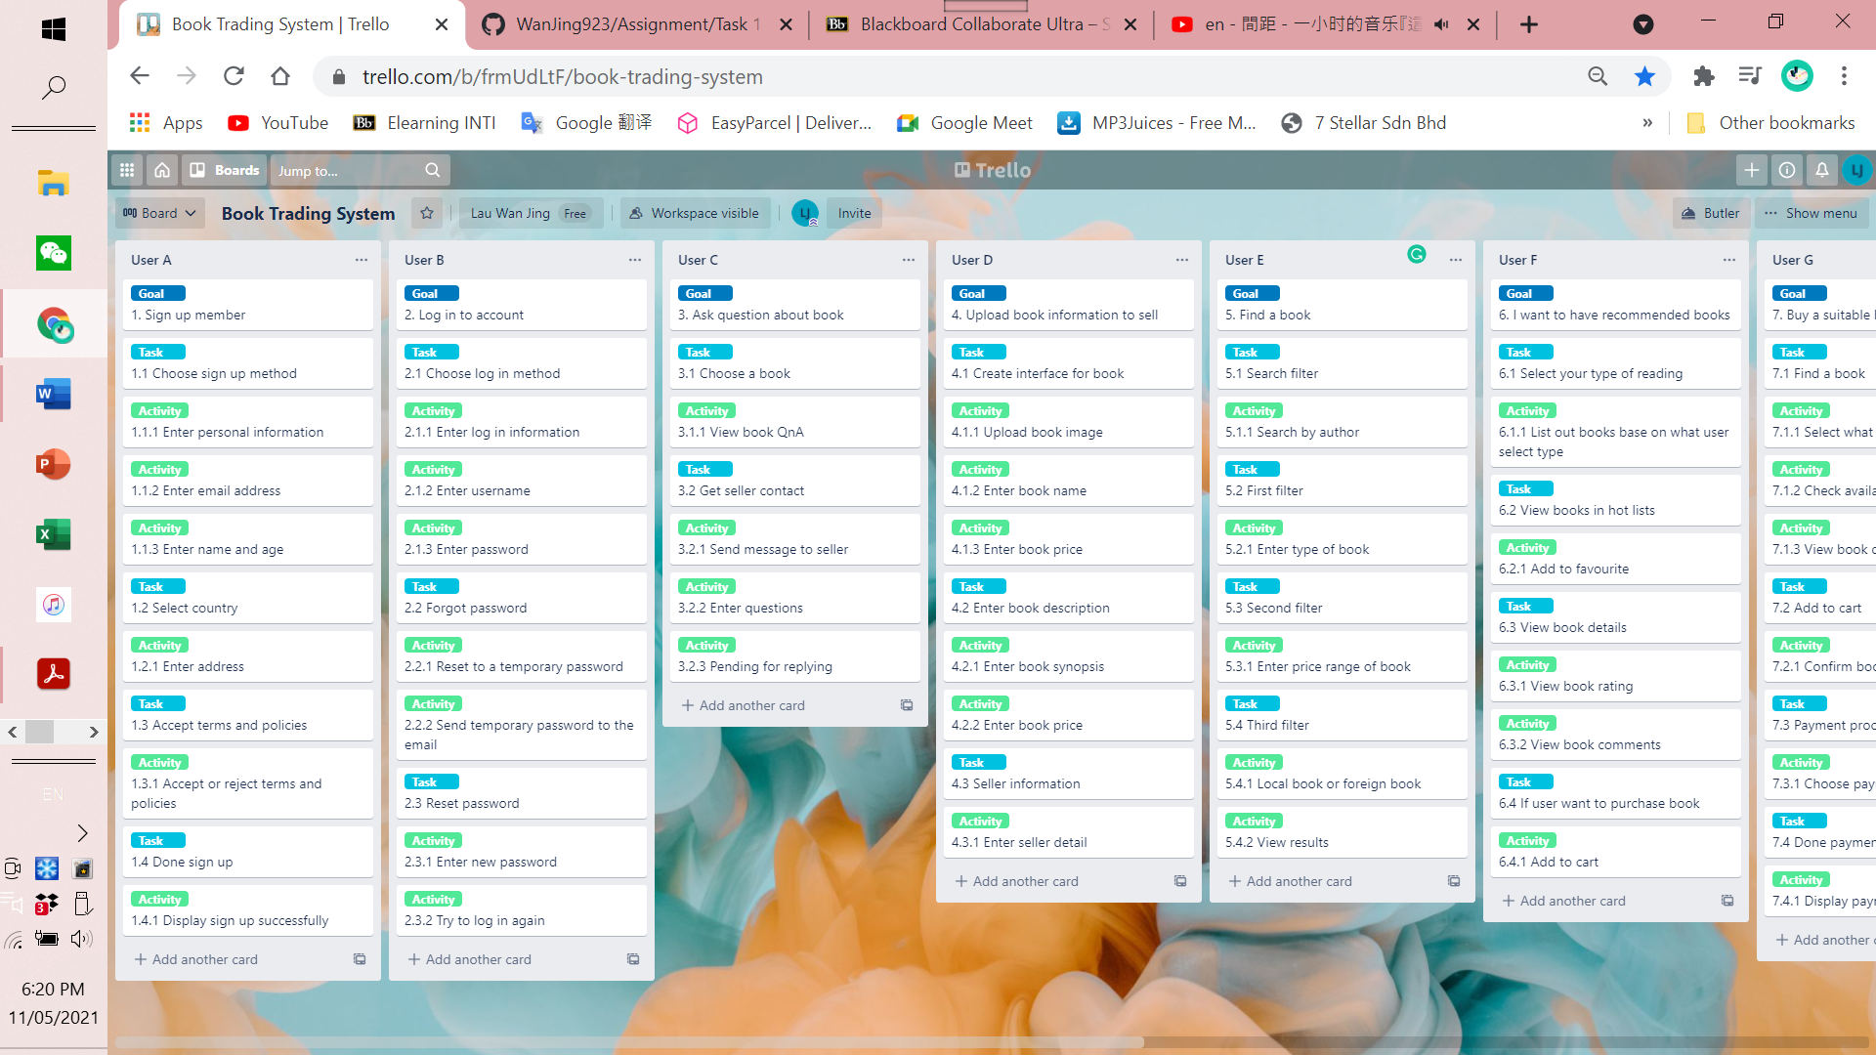

User story 1- User A

Goal: Sign up as member.

Enter personal information to register account.

User story 2- User B

Goal: Log in account.

Reset password if forgot password.



User story 3- User C

Goal: Contact seller to ask questions.

User story 4- User D

Goal: Upload book information for selling.

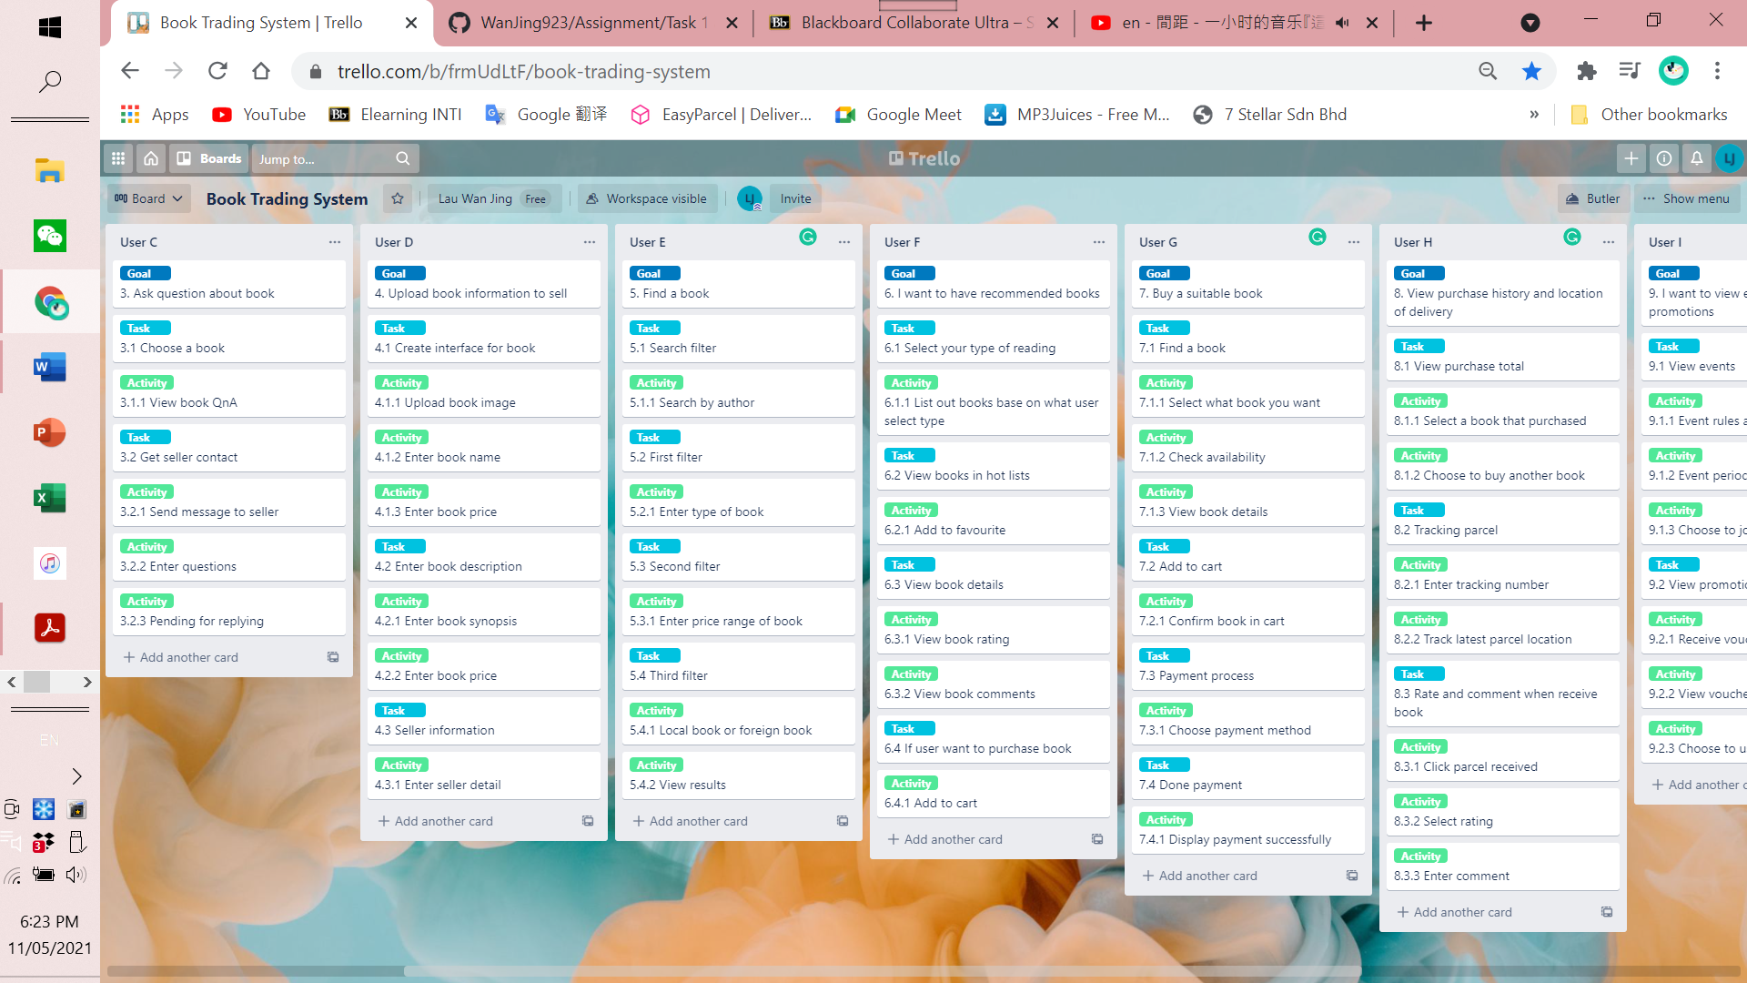

User story 5- User E

Goal: Find a book with filter characteristics.

User story 6- User F

Goal: Find book that recommended to read base on what users like.

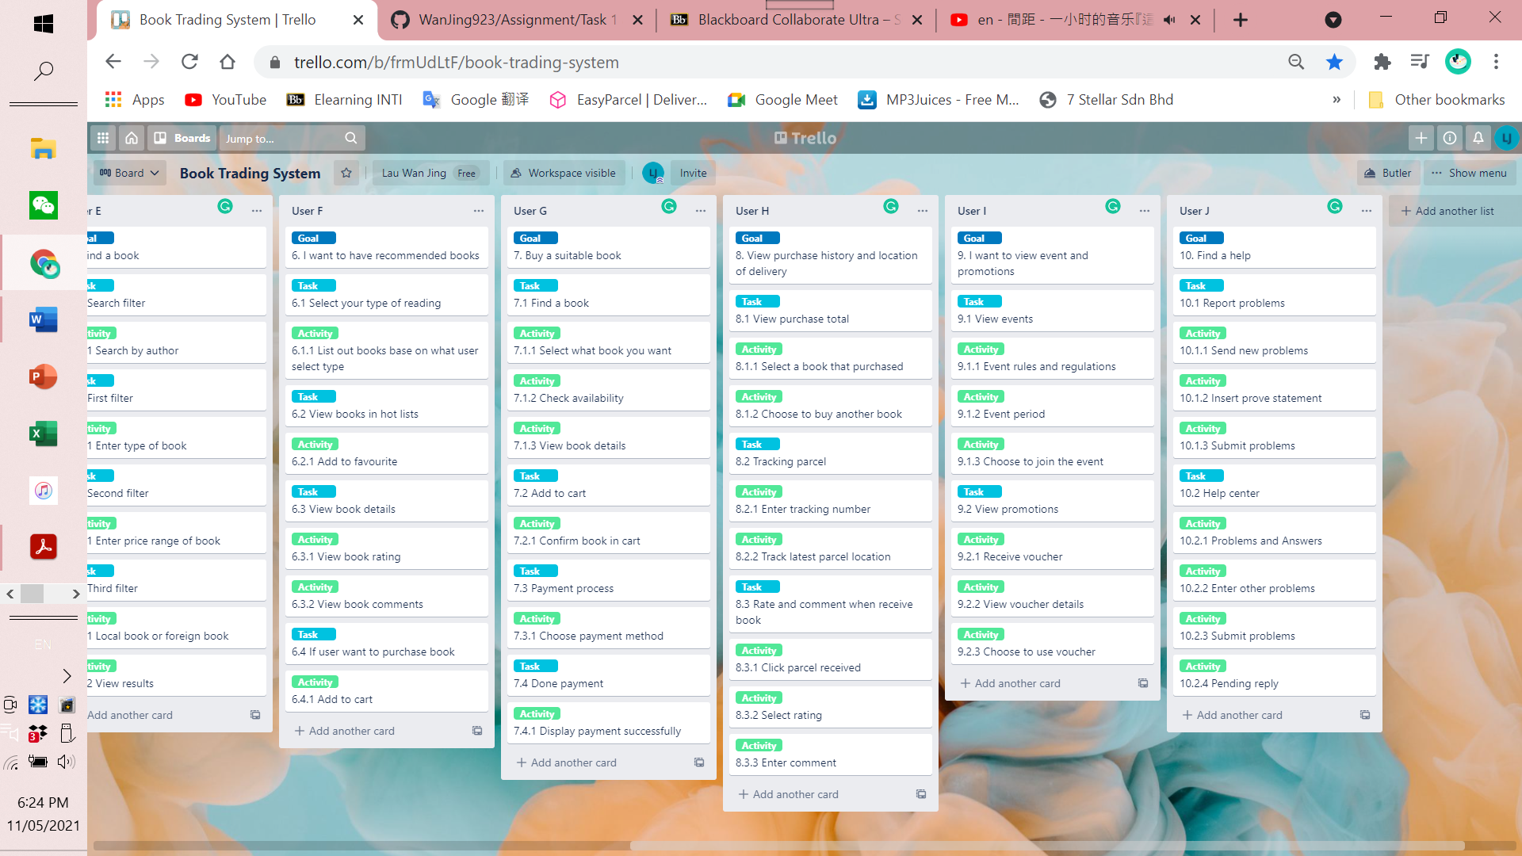

User story 7- User G

Goal: Purchase a book and done payment.

User story 8- User H

Goal: View my purchase history and track my parcel location for receiving parcel and give review.

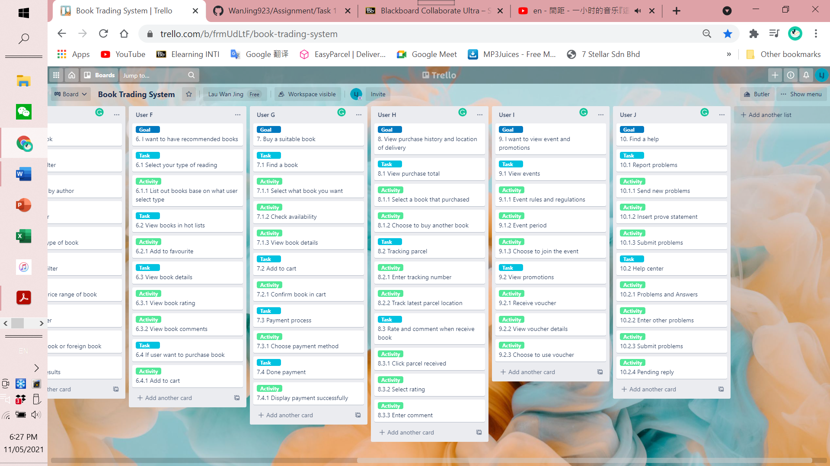

User story 9- User I

Goal: View events and promotions details.

User story 10- User J

Goal: Find a help from system when facing problems.